Phase 5
Capstone Project VAPT Report

Scope & Objectives
The Objective of this Project is to perform controlled Penetration testing on DVWA (Damn Vulnerable Web Application). The Test follows PTES methodology with goals to detect ,exploit and capture any vulnerabilities in the DVWA database.

Methodology
- Reconnaissance
The DVWA website is analysed to find attack vectors. Page structure and input box were tested and using developer tools captured cookies regarding PHPSESSID and security.

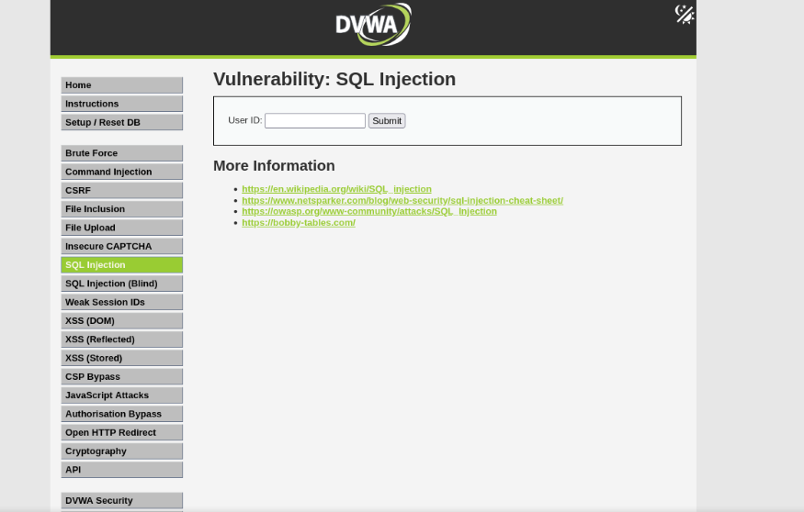
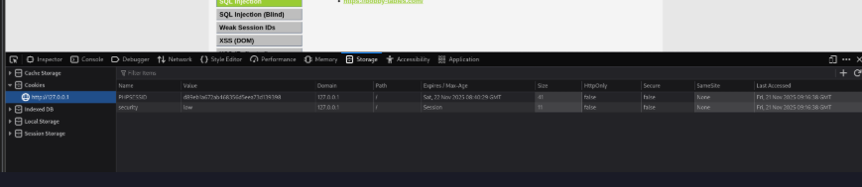

- Vulnerability Discovery
The User Id input field is discovered to be vulnerable to SQL injection. This Parameter is used to perform SQL injection using sqlmap.
- Exploitation
SqlMap was authenticated using the cookie sessions.

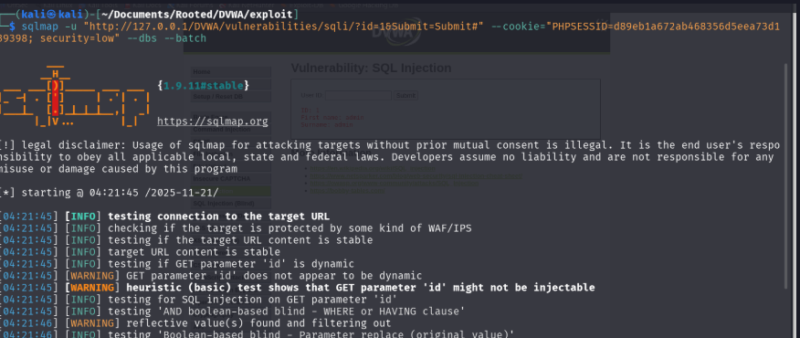

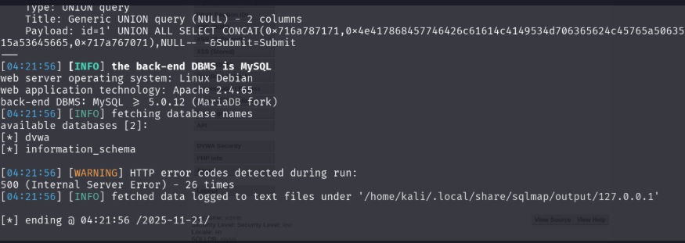

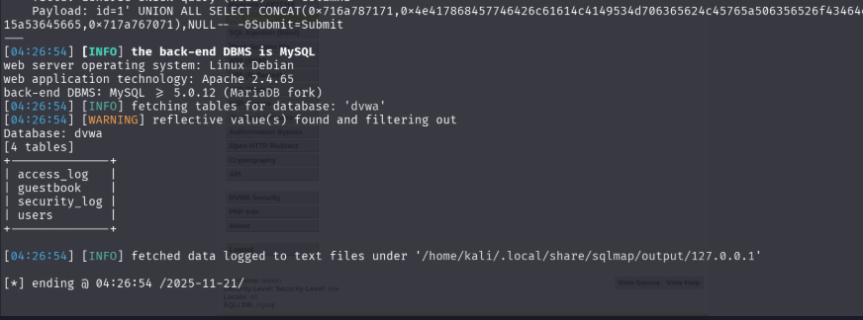

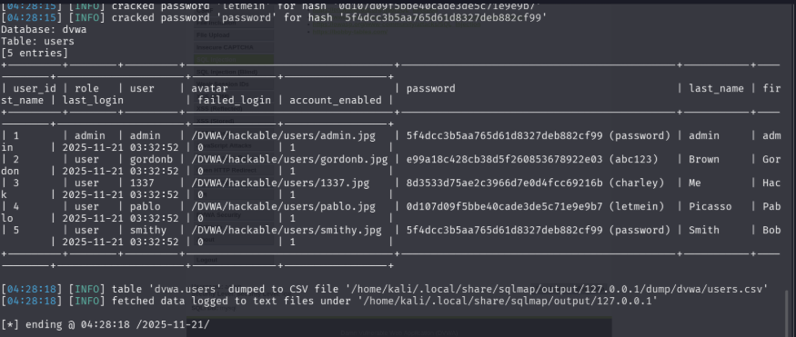

Results:
- Database was found dvwa
- Techniques used were i) Time Based blind ii) Union Based SQLi
- DBMS : MySQL Maria DBfork

SQLmap Enumeration:
- Tables discovered were users, guestbook, security_log, access_ log.
- All user table was dumped.

Extracted Password Hashes:
- 5f4dcc3b5aa765d61d8327deb882cf99 password
- e99a18c428cb38d5f260853678922e03 abc123
- 8d3533d75ae2c3966d7e0d4fcc69216b charley
- 0d107d09f5bbe40cade3de5c71e9e9b7 letmein

Findings
Vulnerability: SQL Injection
Severity: Critical
Vector: ‘Get /vulnerabilities/sqli/id?’
Impact:
- Full Database exfiltration
- Credentials stolen
- Database could be manipulated
- Privilege could be escalated

Remediations
- Implement Prepared statements
- Enable Server-side input sanitization
- Apply Access control policy on users accessing the databases.

Conclusion
The penetration test was successfully done. SQL Injection vulnerability was detected and a small PoC was created and all the steps were recorded. The Test was conducted using the tools Kali Linux Environment, Mozilla Firefox Web browser, Inbuild Developer tools, sqlmap tool. The test resulted in Database exfiltration and the exposure of sensitive user data to the advisory.

Non-Technical Summary:
During the test major SQL injection vulnerability was detected in DVWA web application. One vulnerable input parameter allowed attacker to perform SQL injection. Using automated tools such as SQL map we were able to perform successful penetration test and was able to completely compromise the websites database. All sensitive User data was exfiltrated. The Remediation steps were suggested to better improve the security posture of the DVWA website and Prevent any further SQL Injection Attacks.

